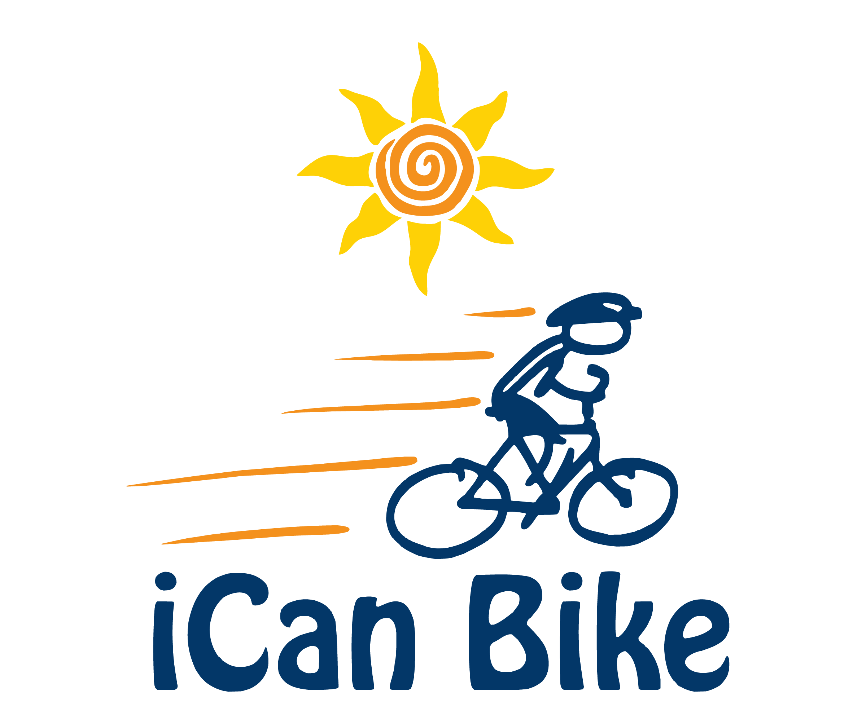
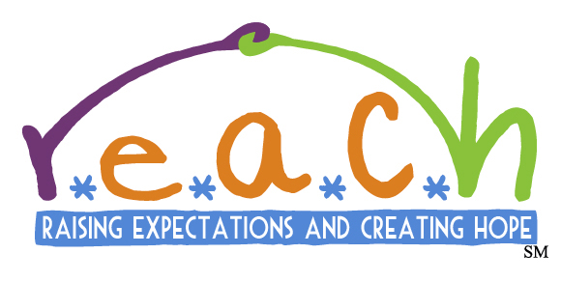

Rider Registration Form
Red River Valley Down Syndrome Society, June 24-28, Love Civic Center

We are pleased to offer this bike program to people with disabilities and look forward to helping your family member learn to ride a two-wheel bicycle independently.
*This is not a guarantee of acceptance into the bike camp

Requirements for Participation (Rider must meet all of below criteria):

- Minimum age - 8 years old | - Able to sidestep to both sides
- Have a disability | - Able to attend camp all 5 days
- Able to walk without assistive device | - Maximum weight 220 lbs.
- Willing and able to wear a properly  fitted bike helmet | - Minimum inseam of 20” (measure from floor while rider is wearing sneakers)

NOTE: Dropping-off Riders at the program is not permitted. A parent, legal guardian or other adult authorized to take responsibility for the Rider (e.g. another parent) must remain on site for the duration of the 75-minute program.

***All fields are required. Registration will not be accepted if this form is incomplete.***

Rider/Family Information:

Rider First Name:
Rider Last Name:
Rider Gender (M or F):
Rider Date of Birth:
Rider Height (in inches):
Rider Weight:
Rider Inseam (inches from floor while wearing sneakers):
Rider T-Shirt Size:
Parent/Guardian First Name:
Parent/Guardian Last Name:
Parent/Guardian E-Mail:
Parent/Guardian Phone:
Parent/Guardian Cell Phone:
Home Street Address:
Home Address City, State, Zip:
Emergency Contact Name:
Emergency Contact Phone:

Disability Information:

Primary Diagnosis:
Secondary Diagnosis, if any:

Please provide detailed information regarding the above diagnoses that will help us work with the rider effectively (box will expand if more room is needed):

Health Information:

Rider Food Allergies, if any:

Please explain any health/medical conditions or health concerns and any special instructions (box will expand if more room is needed):

Choose A Session:

Please number each session in order of preference (i.e. 1st, 2nd 3rd). Only mark the sessions you are able to attend:

Session #1: 8:30 am – 9:45 am
Session #2: 10:05 am – 11:25 am
Session #3: 11:45 am – 1:00 pm
Session #4: 2:00 pm – 3:15 pm
Session #5: 3:35 pm – 4:50 pm

Payment Information:

A $75 deposit (returned last day of camp) is required to process the registration form. Please include check of payable to RRVDSS OR complete below Credit card information for host to input/transact:

Name on Credit Card:
Credit Card #:
Expiration Date:
Security Code:
NOTE: There is intentionally a page break here to ensure credit card information (above) does not appear on same page as Rider Information (below) that is printed and shared with Volunteer Spotters

Rider Information
(NOTE: All of the following Rider information is disclosed orally and/or in print form to the Rider’s Assigned Volunteers. Please do not include any information below that you do not consent to being disclosed to the Rider's Assigned Volunteers)

This information helps camp staff & volunteer spotters assigned to work directly with the Rider understand and better serve the individual needs of the Rider.

Rider Name:
Nickname, if any:
Age at Time of Camp:
Diagnosis (optional):

Please place an ‘X’ in the box that most appropriately describes the Rider:

Generally speaking, the Rider…. | Yes | Sometimes | No
can communicate his/her needs
when upset, can manage his/her emotions
follows simple directions
cooperates with others
Is comfortable with physical queues/prompts
responds positively to playful banter
benefits from use of pictures to convey meaning
gets frustrated easily
has trouble staying focused
gets upset by visual or audio stimuli (e.g. bright lights, loud noise)
gets upset by background noise such as music or talking
Comments/Additional Information (box will expand if more room is needed):

Please answer each of the following questions (boxes will expand if more room needed):
1. What strategies do you use to promote positive behavior and/or discourage negative behavior that will enable us to work safely and successfully with the rider?
2. What are favorite activities, movies, music, hobbies or other interests of the rider?
3. Has rider previously attended an iCan Bike program (formerly Lose The Training Wheels)?
⎕Yes ⎕No
If yes list year(s):
Describe outcome:
4. Has he/she ridden with training wheels? (Yes/No)
If yes, please provide a brief history.
5. Has rider experienced a bicycling accident? (Yes/No)
If yes, please explain.
6. Through participating in this iCan Bike program, what are your expectations for your rider?

Rider Acknowledgment & Liability Release

Rider Name: ________________________________________________

Rider’s Parent/Legal Guardian Name: ____________________________________

The undersigned hereby agrees to the following:

1. Assumption of Risk:

I,________________________, am the above indicated Rider’s parent or legal guardian and, for myself and on behalf of said Rider, have fully read the accompanying iCan Bike Rider Registration Form and the related materials made available to me describing the iCan Bike program (“Camp”), and I am aware of, understand, and assume the unavoidable risks of the inherently dangerous activity of bicycling, which involves movement and physical exertion that could result in, but not be limited to, severe bodily injury or death.

2. Release of Liability:

In consideration of iCan Shine, Inc. (“iCan Shine”), its affiliates the Red River Valley Down syndrome Society (RRVDSS), and the Love Civic Center allowing the above named Rider’s and MY participation in the Camp, I, for myself and on behalf of said Rider, our heirs, administrators, personal representatives or assigns, hereby agree to release, indemnify, hold harmless and discharge iCan Shine, its owners, agents, employees, officers, executives, directors, representatives, affiliates, assigns, Rainbow Trainers, Inc., RRVDSS, the Love Civic Center, and their volunteers, agents, employees, and officers of and from all claims, demands, causes of action, and liability, whether the same be known or unknown, anticipated or unanticipated, even if caused, in whole or part, BY THE NEGLIGENCE OF ANY OF THE FOREGOING. I further agree that I shall not bring any claims, demands, legal action and causes of action, against iCan Shine and/or any of the foregoing for any economic and non-economic losses due to bodily injury and/or death and/or property damage, sustained by said Rider or ME in relation to the facility and/or operations of the Camp, which shall include, but not be limited to, riding, driving, training, handling, or otherwise being near both conventional two-wheeled bicycles as well as the adapted and/or modified biking equipment used by iCan Shine at the facility during the Camp, whether or not such bicycles and equipment are owned by iCan Shine, or in the care, custody, or control of iCan Shine.

3. Indemnification:

If, despite this release, I, the above named Rider or anyone on said Rider’s behalf makes a claim against iCan Shine or any of the foregoing, I agree to indemnify and hold harmless iCan Shine and the foregoing from any litigation expenses, attorney’s fees, loss, liability, damage, or cost that they may incur due to the claim(s) made against iCan Shine and the foregoing related to any of the activities or associated activities outlined above.

Further, I hereby expressly acknowledge that photographs and/or videos of said Rider could be taken by parties outside the control of iCan Shine and RRVDSS in connection with participating in the Camp. I acknowledge that iCan Shine and RRVDSS have limited or no control over such activities of third parties and have no control over any editing and/or use of such photos and/or video footage.

Signature of Rider’s Parent/Legal Guardian: ______________________________

Media and Data Collection Release

I give permission for said Rider to be photographed and/or videotaped and later published in print or electronic media by iCan Shine or RRVDSS or third parties acting on behalf of iCan Shine or RRVDSS. I acknowledge and agree that photographs and videos may be edited and used in whole or in part as desired for these purposes, and may be produced, duplicated, distributed and used for informational, promotional, or other public purposes. I understand that photographs and videos are not my property and I will not be compensated for them. I understand and authorize the use in writing or otherwise the name or identity of said Rider.

Signature of Rider’s Parent/Legal Guardian: ______________________________

Submission Instructions:

Please mail this completed registration form with payment to RRVDSS, PO BOX 6455 Paris, TX 75461 or e-mail to rsutton@rrvdss.org.
You can also send email to tphillipsag98@gmail.com or if you have questions you can contact Tiffany Phillips at 903-517-1649

